ECR:



Codebuild auto trigger:



Kubernetes deployed services:



Kubernetes running pods:

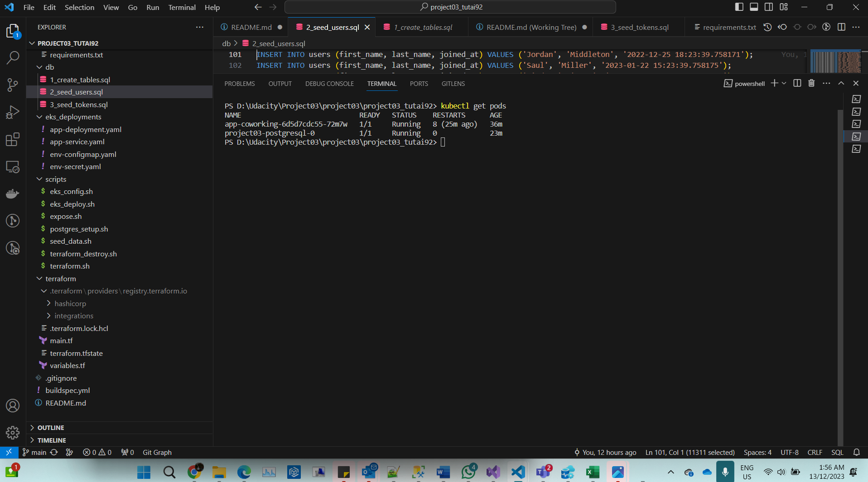

K8 deployment describes:  
  
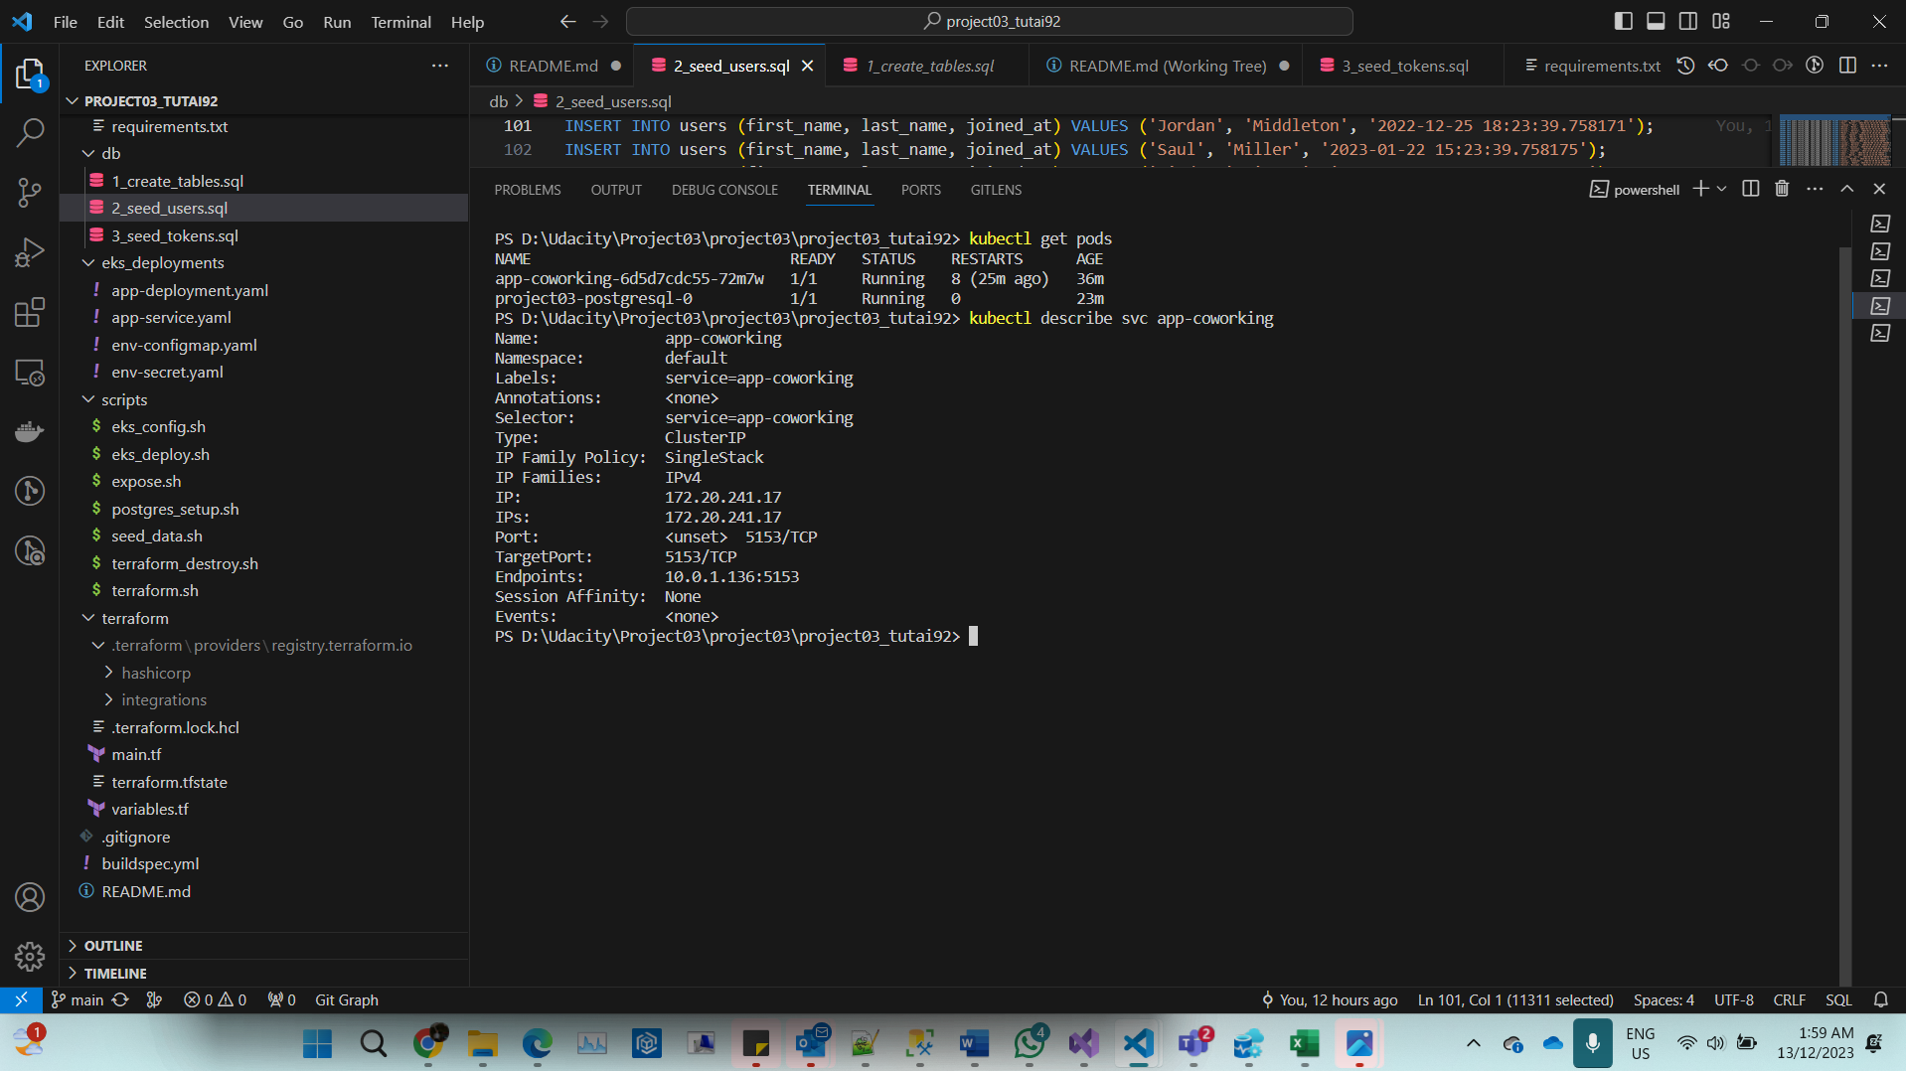

K8 db setup with Helm:



Loggin in CloudWatch:

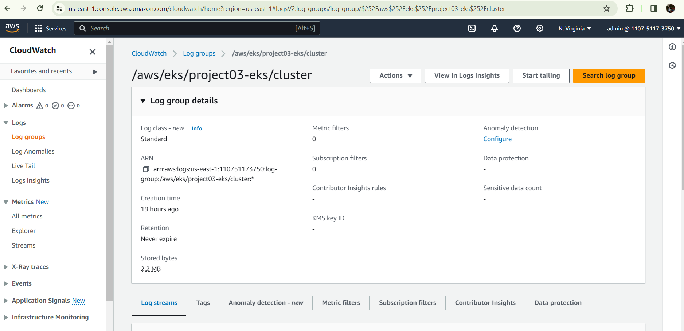

API results:   
  
